# Move files to project Backup Data folder

* All MCD files must be placed in the Backup Data drive (E:\)
* Files should be grouped in the following folder hierarchy: project > merged/unmerged > date > tissue
  + Date folder names should be formatted like “yyyy-mm-dd”
  + Tissue folder names should be formatted like “date_mouse1” or “date_retina1” or “date_tissue1” or something similar
* Merged vs. unmerged
  + MC_Rack automatically splits recordings into multiple files
  + These files should be grouped into the above hierarchy inside the “unmerged” folder
  + Files will be merged in the next step and placed into the “merged” folder
  + If recordings were short enough that MC_Rack didn’t split them, then having folders called merged/unmerged is unnecessary
* Here’s what the Backup Data folder hierarchy looked like on 2016-06-28:

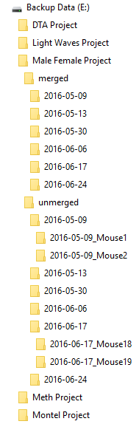

# Merge files with MC_DataTool

* MC_Rack automatically splits recordings into multiple files
* Use MC_DataTool to merge these files back together
* Once in MC_DataTool…
  + Click “Open multiple files”

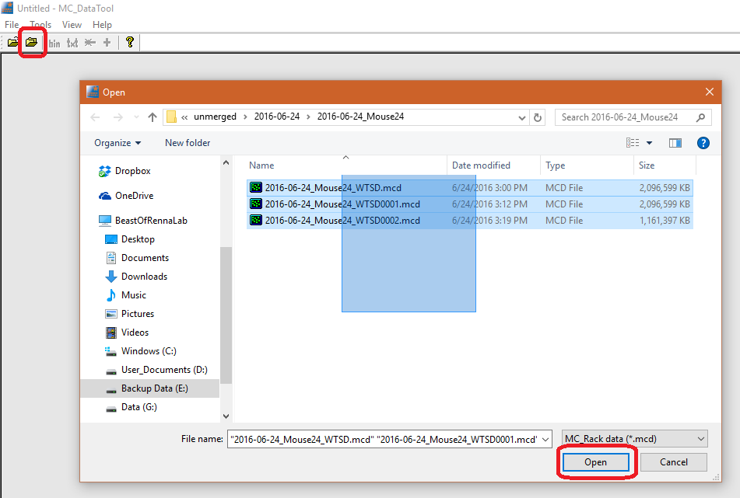

* + Click “Merge multiple files”
    - Don’t worry about the order, MC_DataTool figures this out on its own
  + Save the merged file with “_merged” appended to the name inside the “merged” folder

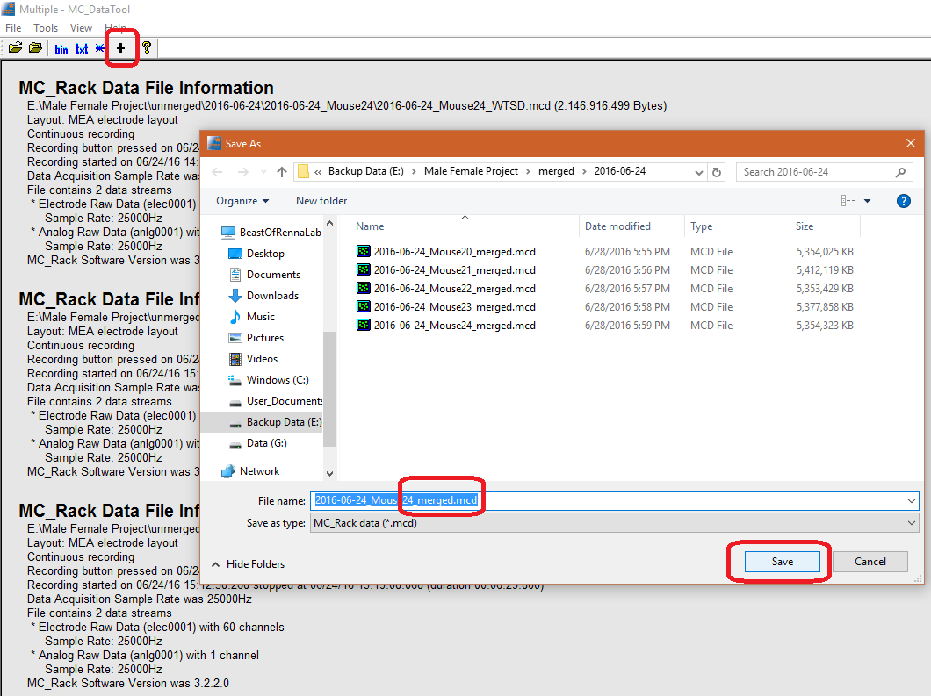

# Log metadata in project Summary workbook

* We should try to keep some minimal “lab notebook” type of info along with all the backup data
* Each project folder inside Backup Data will get its own workbook called “ProjectName_Summary” to keep this information/metadata
* This workbook should have four sheets
  + Populations
    - This sheet defines *experimental* populations, like wildtype and knockout, or test and control
    - For each Population, give it a unique ID (preferably just 1, 2, 3, etc.), a name, and an abbreviation (name and abbreviation can be the same)
    - Also identify one, and only one, population as the control by putting something in its Control column (like an “x” or a “1”)
    - Any formatting applied to the cells in the ID column will also be applied to charts and figures later on
  + Tissues
    - This sheet logs metadata about the actual tissues
    - For each tissue, give it a unique ID (preferably just 1, 2, 3, etc.), a name, the date it was prepared, and the animal’s, sex, and genotype
    - Any additional info can be placed in the Comments (though we may need to add more columns in the future)
    - Technically, the only columns that MUST have values for future analysis are the ID cells, but again, this workbook should ideally serve as a virtual lab notebook
  + Recordings
    - This sheet logs metadata about recordings of each tissue
    - For each Recording, give it a unique ID (preferably just 1, 2, 3, etc.), associate it with a Tissue by providing a Tissue ID from the previous sheet, provide which MEA was used for the recording, under what conditions the tissue was recorded, and the Duration of the recording (easily obtained by opening a merged file with MC_DataTool)
    - The Conditions column is intentionally vague
      * The conditions we’re interested in for one study may or may not be relevant to a future study, so keep track of anything that seems even slightly significant (temperature, light intensity, etc.)
      * This may get broken up into more columns in the future
    - Having StartStamp and EndStamp columns is optional, but will make future analysis easier
      * These columns just log the start and end timestamp of the recording, respectively, and can be calculated automatically with some formulas
      * Note that Durations are for the *entire* recording, i.e. if a recording got split into 3 files that were then merged with MC_DataTool, provide the Duration of the merged file
    - Anecdotal notes, like a computer error or equipment malfunction, should be placed in the Comments column
  + Invalid_Units
    - This sheet is pretty self-explanatory, but we will deal with it later

# Create OFB scripts in project Data folder

* Rather than opening each MCD file in Offline Sorter one at a time, we can use scripts to batch process multiple files at a time
  + These scripts sequentially process all the files in a directory (but none of its subdirectories)
  + Thus, because we organized our MCD files into multiple folders, we will need to create multiple Offline Sorter Batch (OFB) files…one for each folder
  + Making the same script over and over with one-line differences is tedious and error prone, so we can make all the scripts by running another script!
* Run the OfbGenerator.cmd script
  + As of 2016-06-28, this script is located at “D:\Dan_Programming\Programs\WaveAnalysisScripts\BAT_and_OFB_Files”
  + Just double click it to start it
  + Follow the directions in the script
    - Generally, you’ll use the project folder in Backup Data for the first folder
    - The template OFBs are in the same folder as this script; their names describe what they do, so choose an appropriate one for the recordings in this study
    - You can save the generated OFB files wherever, but it’s a good idea to start setting up a project directory now for future results
    - Quotation marks around paths are not necessary
    - You can ignore errors like “The system cannot find the path specified.” Eventually those messages won’t show, but the script is still working.

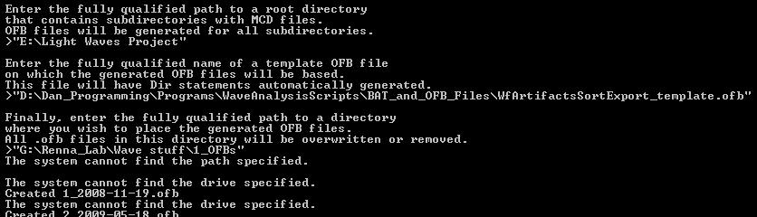

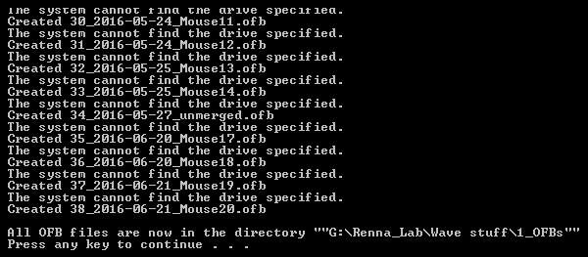

* The script generates an OFB file for *every* sub-directory of the one you specified, some of which may not actually have MCD files in them
  + The name of the directory becomes the name of the OFB file (that’s why having unique folder names is so important)
  + So you’ll want to remove any OFB files that correspond to empty folders or folders with bad data
* Organizing the project folders
  + These folders should be on the Data drive (G:\), and *NOT* in the Backup Data drive with the MCD files (that would fill up the backup drive way too quickly!)
  + If you use different template OFBs or start making your own then you may want to have separate folders for each Offline Sorter “setup” like in the screenshot below
  + The screenshot below shows how folders were organized for the “DTA” study in 2016

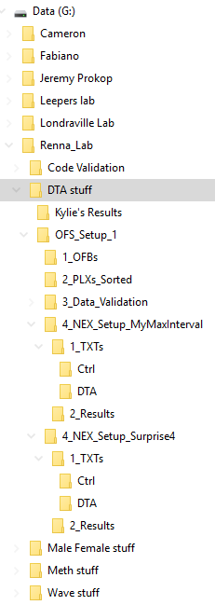

# Run data through Offline Sorter

* For maximum throughput, run a separate window of Offline Sorter for each OFB file
  + In each window, click File > Execute Batch Command File…
  + Select an OFB file from the dialog and click open
  + NOTE: once you start the batch process, you will *NOT* be able to cancel it! There will be a dialog with a cancel button, but it’s like impossible to click it for some reason…
  + You’ll also want to put a sticky note or something on the computer so people don’t sign off in the middle of processing…this will take HOURS!!

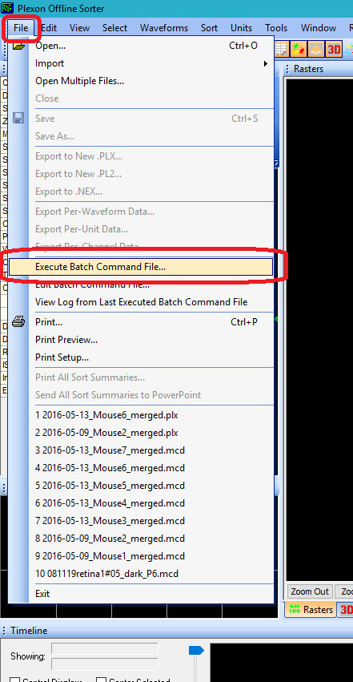

* When all windows have finished…
  + You will see a bunch of log files inside your folder with the OFBs, these logs can be deleted
  + Any files exported by the batch scripts (as PLX files) will be in the same folder as the MCDs, like in the screenshot below

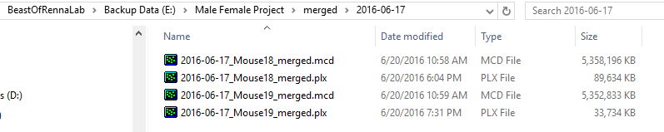

* + Move these PLX files into your project folder on the Data drive (preferably in a folder called “PLXs” or something similar), to save space on the Backup Data drive

# Run data through NeuroExplorer

# Log metadata in project PopRecordings workbook

# Determine invalid units for each recording

# Run data through Excel

# Perform statistics and pretty up figures